**Lab report no 5**



**Fall 2022**

# Control System Lab

**Submitted By**

**Name Registration No**

# Muhammad Ali 19pwcse1801

Section: **A**

**Date**: 09,11,22

**Submitted to: Dr Muniba Ashfaq**

Department of Computer Systems Engineering

University of Engineering and Technology, Peshawar

**Objectives: -**

* To understand differentiation of the system.
* To learn how to find differentiation with initial condition.

**Task no 1: -**

**Code: -**

function dy = func1(t,y)

dy = zeros(4,1);

dy(1) = y(1)+y(2);

dy(2) = y(3);

dy(3) = y(2)+y(3);

end

**Calling file: -**

[t y] = ode23('func1', [0 40],[2 1 1]);

plot(t,y)

**Plot: -**

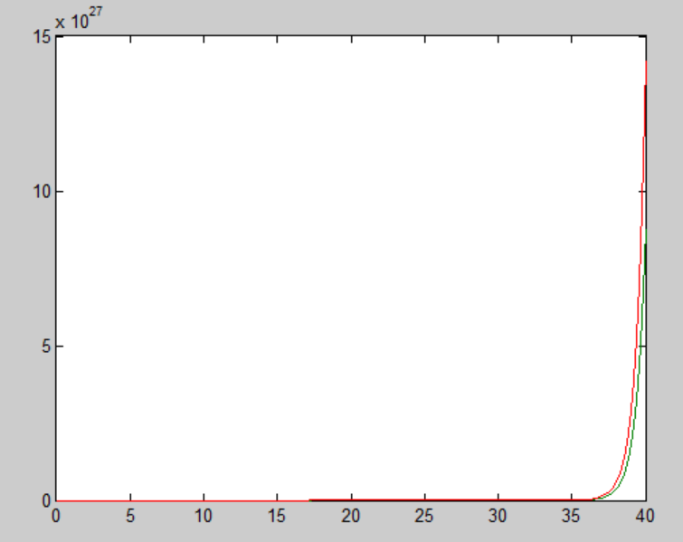

**Task no 2: -**

**Code: -**

function dy = func1(t,y)

dy = zeros(2,1);

dy(1) = y(2);

dy(2) = y(3);

dy(3) = y(2)+2*y(3)-y(1)+2;

end

**Calling file: -**

[t y] = ode23('func1', [0 40],[0 2 1]);

plot(t,y)

**Plot: -**

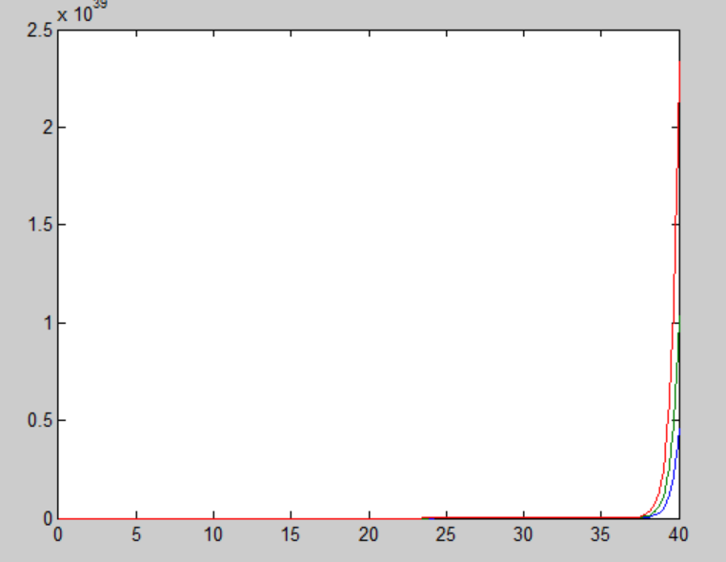

**Task no 3: -**

**Code: -**

**m file(named func1): -**

function dy = func1(t,y)

dy = zeros(4,1);

dy(1) = y(2);

dy(2) = y(3);

dy(3) = y(4);

dy(4) = y(5);

dy(5) = -2*y(5)-24*y(4)-48*y(3)-24*y(2)-20*y(1)-10;

end

**Calling file: -**

[t y] = ode23('func1', [0 40],[2 5 10 -4 -7]);

plot(t,y)

**Plot: -**

